SAMUEL DAVID BADER
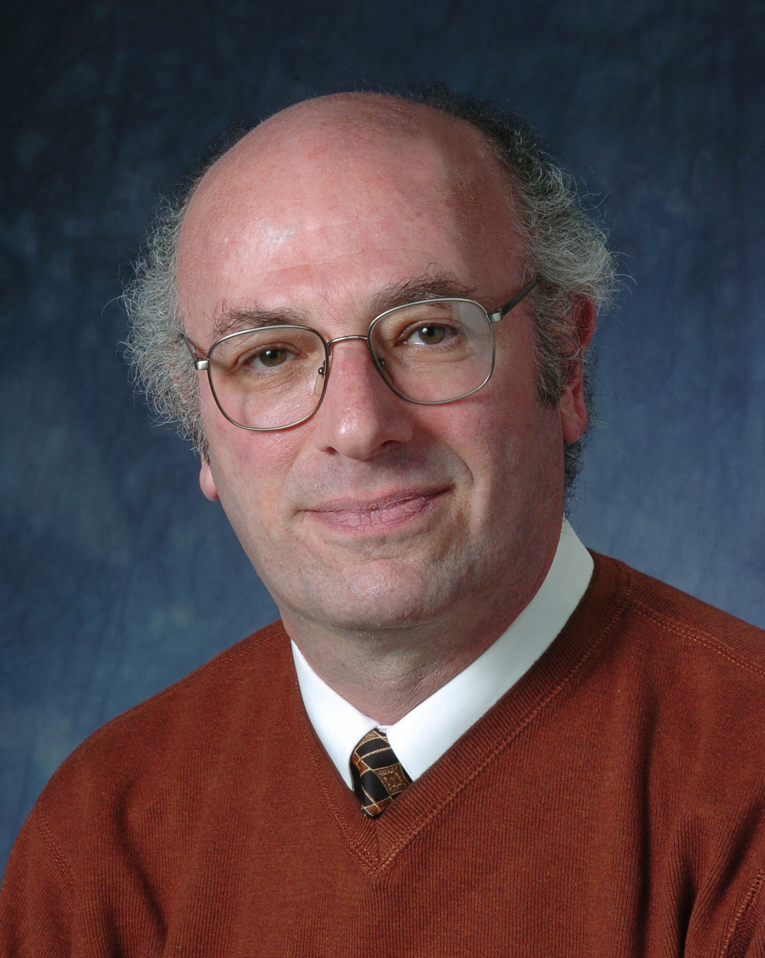
Materials Science Division - Bldg. 223
Argonne National Laboratory
Argonne, Illinois 60439 U.S.A.

Telephone: (630) 252-4960
FAX: (630) 252-5219
e-mail: bader@anl.gov

Sam Bader is an Argonne Distinguished Fellow, Magnetic Films Group Leader, and Associate Director of Argonne National Laboratory's Materials Science Division. He is also Chief Scientist for Argonne’s Center for Nanoscale Materials. He received B.S. (1967) and Ph.D. (1974) in Chemistry from the University of California, Berkeley, where in graduate school he worked on f-electron magnetic and superconducting systems at low temperatures. His current research interests include creating novel hybrid permanent magnets, and exploring laterally confined nanomagnets in order to develop magnetic electronics and bio-inspired, self assembled magnetic nanostructures. He has coauthored over 350 papers (h=52). He is a Fellow of the American Physical Society (APS) and of the American Vacuum Society (AVS). His honors also include a U.S. Department of Energy – Basic Energy Sciences Award for Outstanding Achievement in Solid State Physics, the AVS Thornton Memorial Award, and the APS David Adler Lectureship Award. He is an Adjunct Professor in the Department of Materials Science and Engineering at the University of Illinois, Urbana-Champaign, and in the Department of Physics and Astronomy at Northwestern University in Evanston, Illinois. He is a former Chair of the APS Division of Materials Physics, and will assume the Chair of its Division of Condensed Matter Physics in 2011. He recently chaired the Scientific Advisory Committee of the Advanced Light Source synchrotron in Berkeley, California. He was a member of the physics decadal study committee in Condensed Matter and Materials Physics (CMMP2010) of the National Academies. He is on the Advisory Board of the National Science Foundation-funded National Nanotechnology Infrastructure Network. He is an Associate Editor of Applied Physics Letters and Editor-in-Chief of the Journal of Magnetism and Magnetic Materials.

Prof. Pamela Anne Thomas
Dept of Physics
University of Warwick
Coventry CV47AL

Office: 011-44-2476-523354
Fax: 011-44-2476-692016
Email: p.a.thomas@warwick.ac.uk

Yasuhiko Fujii
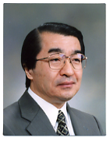
Director General, Quantum Beam Science Directorate,
Japan Atomic Energy Agency (JAEA)
2-4 Shirakata-Shirane, Tokai, Ibaraki 319-1195
Japan

Phone: +81-29-284-3815
Fax: +81-29-284-3822
Email: fujii.yasuhiko@jaea.go.jp

Yasuhiko Fujii is a Director General of Quantum Beam Science Directorate, Japan Atomic Energy Agency (JAEA, the former Japan Atomic Energy Research Institute), responsible for scientific research based on the JAEA-owned large-scale beam facilities such as JRR-3 Reactor, Japan Proton Accelerator Research Complex (J-PARC), TIARA Ion-Beam Facility, J-KAREN Laser Facility, and SPring-8 Synchrotron Radiation Facility. He is also an Emeritus Professor of Tokyo University since 2004. His major research field is experimental solid state physics and materials science, in particular, neutron and x-ray scattering study of phase transition in spin-charge-lattice coupled systems with interactive frustrations and in metallization and molecular dissociation of molecules under extreme conditions. Recently he has been working on forming the “Quantum Beam Platform” bridging large-scale beam facilities such as accelerators and rectors for comprehensive users programs from academic research to industrial/medical application. Fujii received Ph.D in Physics from Osaka University in 1973. He was a Research Associate of Institute for Solid State Physics at Tokyo University in 1970-1978, an Assistant/Associate Physicist of Physics Department at Brookhaven National Laboratory in 1979-1982, an Associate Professor of Faculty of Engineering Science at Osaka University in 1982-1988, a Professor of Institute of Materials Science at Tsukuba University in 1988-1992, and a Professor of Institute for Solid State Physics at Tokyo University in 1992-2004 where he served Chair of Neutron Scattering Laboratory in 1993-2002. He moved to Japan Atomic Energy Research Institute as Director of Neutron Science Research Center in 2004 and became the present position in 2007. Fujii was members of Commission on Neutron Scattering and Commission on High Pressure of International Union of Crystallography IUCr in 1996-2005. He served Chair of the former Commission in 1999-2002 and Chair of International Program Committee of the IUCr2008 Congress in 2005-2008. He has been a Japanese Representative for the US-Japan Cooperative Research Program on Neutron Scattering between USDOE and MEXT (Ministry of Education, Culture, Sports, Science and Technology) since 1992. Fujii was the President of Japanese Society for Neutron Science in 2001-2004 and was awarded the Outstanding Contribution to Neutron Science and Technology in 2006. In 2009 he received the Prize for Science and Technology in Neutron and Synchrotron X-ray Scattering Research of Condensed Matters by the Minister of MEXT.

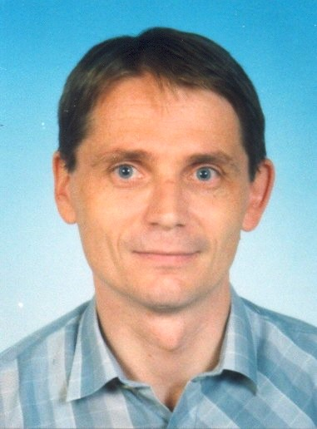
Jiří Erhart

Associate Professor
Piezoelectricity Research Laboratory
Department of Physics and
International Center for Piezoelectric Research
Technical University of Liberec
Studentská 2, CZ-461 17 Liberec 1
Czech Republic

phone: +420-485353400
FAX: +420-485353530
E-mail: jiri.erhart@tul.cz
Web-page: http://www.fp.tul.cz/kfy/erhart.html

Jiří Erhart is an Associate Professor of Physics at the Department of Physics, Technical University of Liberec, Czech Republic. For the last decade, his research interests were focused on the ferroelectric domains and domain engineering, piezoelectricity, electromechanical properties of piezoelectric ceramics and single-crystals and applications of piezoelectric properties in unimorphs, bimorphs, transformers, transducers and ultrasonic motors. He was graduated from the Faculty of Mathematics and Physics, Charles University in Prague, Czech Republic in 1988 (MSc.) in the field of theoretical physics. He got his Ph.D. degree in the field of Solid State and Materials Research from the Institute of Physics, Academy of Sciences of the Czech Republic, Prague and Faculty of Mathematics and Physics, Charles University in Prague in 1999. During 1998-1999 he was Research fellow and postdoc with prof. Wenwu Cao, Materials Research Laboratory, The Pennsylvania State University, University Park, U.S.A. In 2003 he got the Matsumae International Fellowship for the stay at The Tokyo Institute of Technology, Tokyo, Japan. In 2002 and 2004 he was shortly research fellow at City University of Hong Kong, China. He is in charge for the Piezoelectricity Research Laboratory – part of departmental experimental facilities in the field of piezo- and ferroelectricity. Currently he is in charge of 2 Ph.D. students and some classes for Ph.D. students in the field of piezo- and ferroelectricity. During 2002-2007 he was active in the Grant Agency of the Czech Republic – he served as a reviewer of grant projects. Since 2008 he is a commission member-reviewer for the grant projects at funding agency for Czech universities. He also teaches general class in Physics and specialized courses in Theoretical mechanics, Theory of electromagnetic field, Thermodynamics and Statistical Physics and previously also Physics of dielectrics, Piezoelectric materials and Tensors and Group theory. He is in close contact with the first Czech Interactive Science Museum in Liberec (IQ Park, Liberec, http://www.iqpark.cz/en/) – he serves as an advisor for the design of physics experiments there.

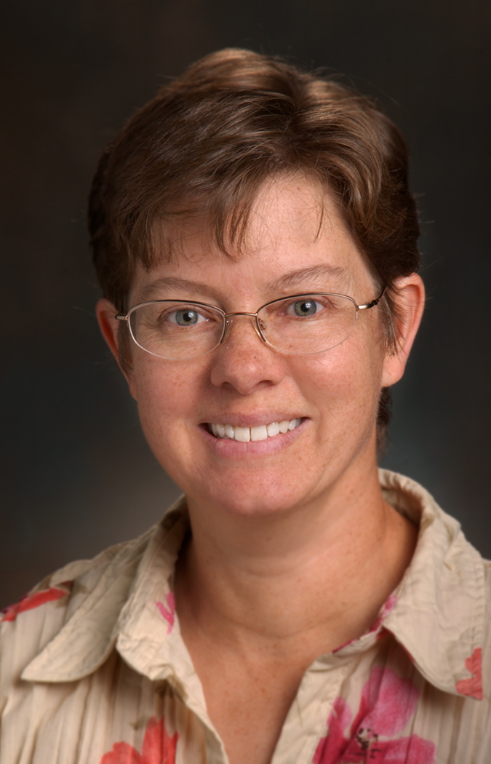
Barbara Frisken

Professor and Chair
Department of Physics
Simon Fraser University
Burnaby BC V5A 1S6

Phone: (778)-782-5767 (office)
Email: frisken@sfu.ca

Barbara Frisken is a Professor of Physics at Simon Fraser University, Burnaby, British Columbia, Canada. She is currently chair of her department. Her research interests center on studies of structure and dynamics in soft condensed matter and the relation between microstructure and material properties. She has studied electric and magnetic properties of liquid crystals, phase separation of binary liquids in the presence of quenched disorder, extrusion of lipid vesicles, correlations between conductivity and microphase separation in conducting polymers and competition between phase separation and crystallization in colloids. She completed her PhD at the University of British Columbia in 1987 and spent three years as a postdoctoral fellow at University of California, Santa Barbara, before joining the Physics Department at SFU.

JOAQUIN GARCIA RUIZ

Instituto de Ciencia de Materiales de Aragón
Consejo Superior de Investigaciones Científicas
Facultad de Ciencias, Universidad de Zaragoza
C/ Pedro Cerbuna nº12, 50009 Zaragoza, Spain

Telephone: 34-976-761225
FAX: 34-976-761229
Email: jgr@unizar.es

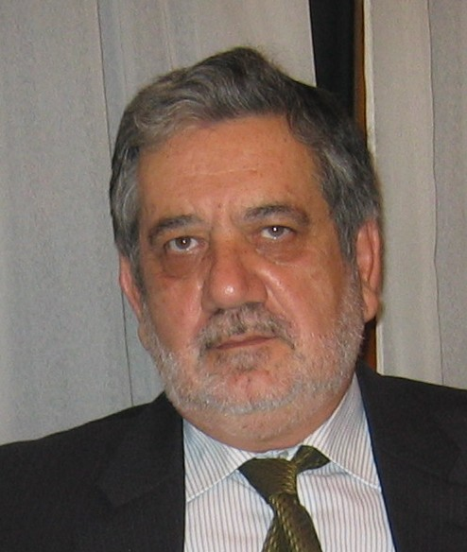
Joaquin García Ruiz is Research Professor at the Instituto de Ciencia de Materiales de Aragón of the Consejo Superior de Investigaciones Científicas. He is leader of the group CAMRADS “Materials Characterization by Synchrotron Radiation”. He received the degree in Chemistry at the University of Murcia and in Physics and PhD in Sciences (Physics) at the University of Zaragoza. His research activity has mainly focused in the study of transition metal oxides with particular emphasis in their microscopic structural and electronic characterization. Metal-insulator, charge ordering, orbital ordering, magnetorresistance, magnetoferroelectricity have been the main topics of his research. His studies involved either the synthesis (including single crystal growth), macroscopic properties ( heat capacity, magnetic and electrical measurements, etc) of the materials and structural and electronic studies using synchrotron radiation. He is expert in techniques such as X-ray Absorption Spectroscopy, X-ray Powder Diffraction, Resonant X-ray Scattering, etc. The recent major contribution is the study of the Verwey transition in magnetite by means of RXS. He has been leader of about 20 research projects and he participated in other 11 projects. He is coauthor of more than 240 papers (h=35). He has been member of the Scientific Advisory Committee of the European Synchrotron Radiation Facility and he is a SAC member of the Synchrotron ALBA in Barcelona and vice-president of AUSE (Spanish synchrotron radiation user association). He has been supervisor of 9 PhD students.

Young Kuk

Professor of Physics and Astronomy
Seoul National University

(tel) +82-2-880-5444
(fax) +82-2-873-7039
email: ykuk@phya.snu.ac.kr ykuk@nist.gov

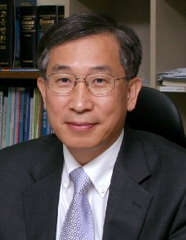
Young Kuk is a Professor of Physics and Astronomy at Seoul National University, Seoul, Korea. He was the research vice president of SNU from 2006-2008. He is on sabbatical leave right now for one year at NIST, Gaithersburg. For the last two decades, his research activity has focused on physics in the nanometer scale mainly with scanning probe microscopy. He has studied 1) the dynamical aspects of chemisorption on clean surfaces, 2) the role of scanning tip in STM, 3) local photovoltage with STM, 4) 1-dimensional nanowires including carbon nanotubes, 5) Nanomagnetism with spin polarized scanning tunneling microscope and 6) Conformal transformation of molecules. He completed his PhD in Physics department at the Pennsylvania State University in 1981. Right after his PhD, he joined AT&T Bell Laboratory as a member of technical staff where he worked for ten years before he joined Seoul National University in 1991. Kuk is the author of over 140 refereed papers, five invited review papers on STM, coauthors in two STM books, and featured articles in Physics today and other journals. He has been members in many in steering committees of Scanning Tunneling Microscope related international conferences from the advent of STM. He has served as an editor of Solid State Electronics, and a member of editorial boards of Nanotechnology, Scanning Probe Microscopy, the Korean Vacuum Society journal, the Korean Physical Society journal. He is a fellow of Institute of Physics, Bohemische Physical Society, the Korean Physical Society and the Korean Vacuum Society. He has received Inchon Award (2008), Korean national fellow award (2006), Korean national academy of science award (2004), 10 most popular scientists award (2004), Erwin Mueller young scientist award (1980), and American Vacuum Society graduate student award (1980).

Jueinai Raynien Kwo

Physics Department
National Tsing Hua University
Hsin Chu, Taiwan 300

03-574-2800 (voice)
03-572-3052 (fax)
e-mail raynien@phys.nthu.edu.tw

Prof. J. Raynien Kwo is currently Distinguished Tsing Hua Chair Professor in the Department of Physics, National Tsing Hua University, Hsin Chu, Taiwan. She is the Director of the Center of the Fundamental Science Research in the University. She has been the President of the Physical Society, Taipei, Taiwan during the last two years. Her primary research field has been on the advances in novel thin film materials physics by nano film growth techniques such as molecular beam epitaxy. Her recent thrust programs have led the global efforts on the alternative high k gate dielectrics for nanoelectronics on Si CMOS, and for high mobility channel semiconductors beyond Si CMOS during last ten years. Raynien completed her PhD degree from the department of applied Physics, Stanford University, CA in year 1981, and joined Bell Labs Physics Research Division in Murray Hill, New Jersey as a member of the technical staff, and later promoted to become the distinguished member of technical staff. In year 2003 she returned to Taiwan, and dedicated to promote the education and research of physics. She has published over 260 papers in SCI major physics and materials journals with a Hirsch Index of 48. She was ranked 746 as the ISI 1120 Most Cited Physicists for years 1981-6/1997. She is the first woman Fellow of the Physical society in Taiwan. Her major research achievements are the following: elucidation of microscopic mechanism responsible for superconductivity in the A-15 compounds by tunneling. (year 1978-81); pioneer in metallic superlattices by inventing metal molecular beam epitaxy. (year 1982-84); the first discovery of modulated magnetic properties and observation of long range magnetic order in synthetic magnetic superlattices, which led to the subsequent discovery of the giant magneto-resistance effect (the Physics Nobel Prize 2007), and revolutionized the magnetic read/storage industry. (year 1985-88); pioneer in oxide molecular beam epitaxy producing single crystalline high temperature superconducting perovskite oxide films for probing anisotropic superconducting properties, and developing Josephson-coupled superconducting devices. (year 1988-1993); discoveries of two new transparent conducting oxides and innovation of thin film process for display and electro-optical devices. (year 1993-1995); innovations of high dielectric constant (κ) oxide thin films of (Ba-Sr)TiO₃ and Ta₂O₅ as micro-capacitors for wireless and DRAM applications. (year 1995-1997); alternative high k gate dielectrics for Si CMOS application beyond 45nm node (year 1997-2006); and the discovery of a mixed oxide GaGdO_{x} dielectrics for III-V compound semiconductors passivation, and first demonstration and developments of III-V semiconductor based MOSFET circuits. (year 1996-2009).

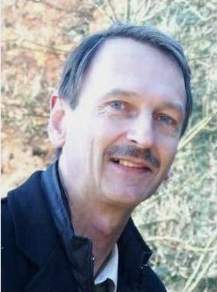
Philippe Lambin

Laboratoire de Physique du Solide
Facultés Universitaires N-D de la Paix
Rue de Bruxelles 61
B 5000 Namur, Belgium

Tel. 081-725242 / 081-725243
Fax 081-725241
Email : philippe.lambin@fundp.ac.be

Prof.Dr. Dragan Mihailovic
Head of Department
Dept. of Complex Matter,
Jozef Stefan Institute
Jamova 39, SI-1000 Ljubljana
Slovenia
E-mail: dragan.mihailovic@ijs.si
Tel.: +3861 477 3388 (sec.) 3729 (direct)
http:\\complex.ijs.si

M.A., Physics, (1979), University of Oxford, Doctorate: D.Phil., (1983), University of Oxford, U.K.
Current position: Head of Department of Complex Matter, Group leader and Chief Scientist at the J.Stefan Institute, Ljubljana, Slovenia, Professor at the Department of Mathematics and Physics, University of Ljubljana, Vice-Dean and Professor at the Josef Stefan International Postgraduate School

He presently leads a mixed experimental-theoretical group within the department of Complex Matter encompassing a variety of research fields, ranging from the synthesis of new materials to fundamental investigations of elementary excitations, self-organising behaviour and adaptive functionality in complex systems. These include anything from nano-biosystems and biomolecules to superconductors and nanowires. The experimental methods used are suitably diverse, from synthetic chemistry to biomedicine, femtosecond laser spectroscopy and magnetometry. The experimental research within the department is strongly supported by theory. Recently, the research activities on new nanomaterials and nanotechnology, such as nanolithography were greatly expanded. Apart from fundamental research, some viable applications have also emerged, particularly in the field of new nanomaterials such as Mosix nanowires.

Oğuz Gülseren

Department of Physics,
Bilkent University,
Bilkent 06800 Ankara, Turkey

Phone: +90-312 290 1937 Fax : +90-312 266 4579
URL : http://www.fen.bilkent.edu.tr/~gulseren
E-mail: gulseren@fen.bilkent.edu.tr

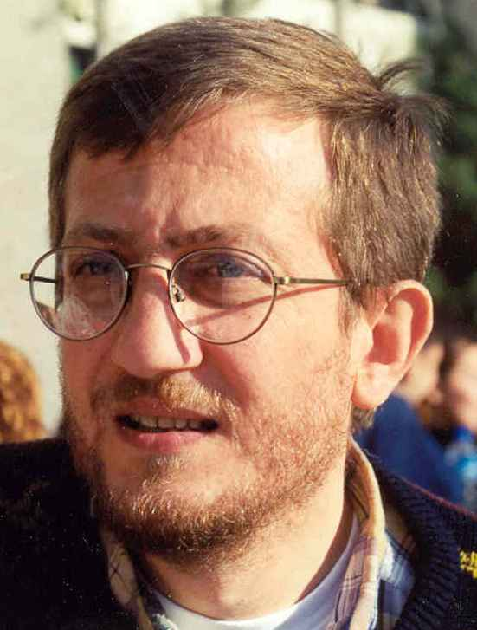
Oğuz Gülseren is an Associate Professor of Physics at Bilkent University, Ankara, Turkey. He received B. Sc. from Electronics and Electrical Engineering Department of Middle East Technical University, Ankara, Turkey (July 1986). After then, he completed his M. Sc (February1988) and Ph.D. (July 1992) in physics from Bilkent University, Ankara, where he worked on the electronic structure of low dimensional semiconductor systems. After then, he worked at SISSA-Italy (Nov. 1992 to Apr. 1995), ICTP-Italy (Nov. 1994 to Apr. 1995), Bath University-UK (Apr. 1995 to Mar. 1998), Carnegie Institution of Washington-USA (Mar. 1998 to Aug. 1999), and University of Pennsylvania and NIST-USA (Aug. 1999 to Aug. 2002). Eventually, he joined Department of Physics, Bilkent University at Sept. 2002. His current research interests include properties of nanostructures like graphene, nanotubes, nanowires, metallic clusters, BN sheets, material properties at high pressure and high temperature, vibrational spectra and thermodynamics of solids, dye sensitized solar cells, atomic scale friction and biomimetic adhesion, and surface chemistry and catalysis from first principles calculations. He has coauthored around 50 refereed papers with an h-index 22. He has received TÜBİTAK- TWAS (Third World Academy of Science) young scientist award (2003), and İstanbul University science award (2002). He has been elected as associate member of Turkish Academy of Sciences, TÜBA, (December 2006). He is also an associate member of the Abdus Salam International Center for Theoretical Physics, ICTP, Trieste, Italy for the period 2005-2010.

Jean-Paul Pouget

CNRS Research Director
Laboratoire de Physique des Solides
Université Paris-Sud
F-91405 Orsay
FRANCE
Email: pouget@lps.u-psud.fr

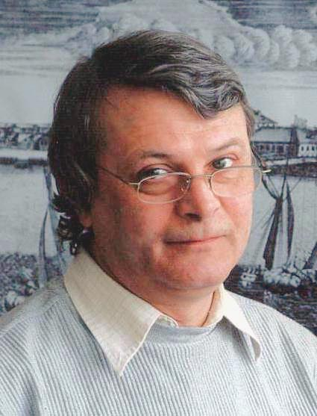Vitaly KVEDER

Institute of Solid State Physics
Russian Academy of Sciences
142432 Chernogolovka, Russia

Telephone: +7 496 522 23 44, +7 496 522 46 46
FAX: +7 496 524 97 01
E-Mail: kveder@issp.ac.ru
www: http://www.issp.ac.ru/

Vitaly Kveder is a Director of the Institute of Solid State Physics of Russian Academy of Sciences (ISSP RAS). He is also head of Laboratory of Spectroscopy of Defect Structures in ISSP RAS. He received B.S. (1972) and Ph.D. (1977) in Physics and Mathematics from the Moscow Institute of Physics and Technology (MIPT). From 1977 till now he works as a scientist in the ISSP RAS first as a researcher, then as a leading researcher, then as a head of Laboratory and from 2002 till now as a director of the Institute. His current research interests include defect engineering in silicon in connection with solar cells technology, especially the interaction of dislocations with point defects and impurities and its influence on electronic and optical properties of dislocations. He also works in the field of electronic, optical and magnetic properties of fullerenes, carbon nanotubes and fullerene-based compounds. He has coauthored over 120 papers. In 1987 he was awarded the degree "Doctor of physical and mathematical sciences", in 1997 he has got a title "Professor of Science” and in 2006 he was elected to Russian Academy of Sciences as a corresponding member. He is a coordinator of a research program “Physics of novel materials and structures” and a member of Scientific Council “Physics of Semiconductors” in Russian Academy of Sciences. He recently chaired the Scientific Council “Physics of Condensed Matter” in Russian Academy of Sciences.

Miklós Tegze

Research Institute for Solid State Physics and Optics
of the Hungarian Academy of Sciences
Budapest, XII., Konkoly Thege M. ut 29-33.
Mail: H-1525 Budapest, P.O.Box 49, Hungary
Phone: +36-1-3922222 ext. 3371
Fax: +36-1-3922219
e-mail: mt@szfki.hu
web: http://www.szfki.hu/~mt/

